7 Mirroring and Joining the Shape

# The Starting Point

We are Starting from this point here, from our last tutorial. Your shape should look like this now, if you are following along from the last tutorial.

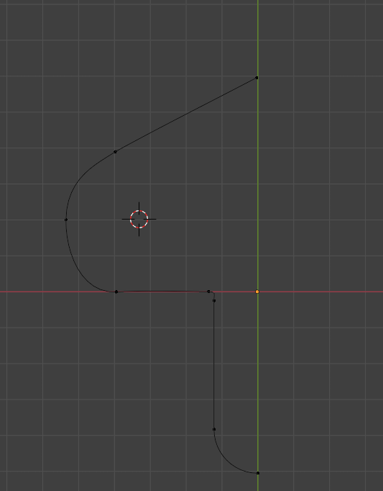

<https://www.youtube.com/watch?v=f53GvpTIO2w>

